Practical - 8
Practical Title: MySQL Schema Design, ER Model, PDO Connectivity, and Prepared Statements

Problem Definition : Design the database for StudentHub with students, events and registrations. Create PHP database connection using MYSQL statements.

Theory
1. Is the schema normalized properly?
Yes, the schema is properly normalized. Each field stores a single value and there is no unnecessary duplicate data.

2. Are primary keys and foreign keys correctly defined?
Yes. The id field is used as the primary key. Foreign keys are not required in the profiles table because it is currently a single independent table.

3. Is the database connection handled securely?
Yes. PDO is used for the database connection and prepared statements are used for inserting data, which helps prevent SQL injection.

A. Evidence of Work (Screenshots):
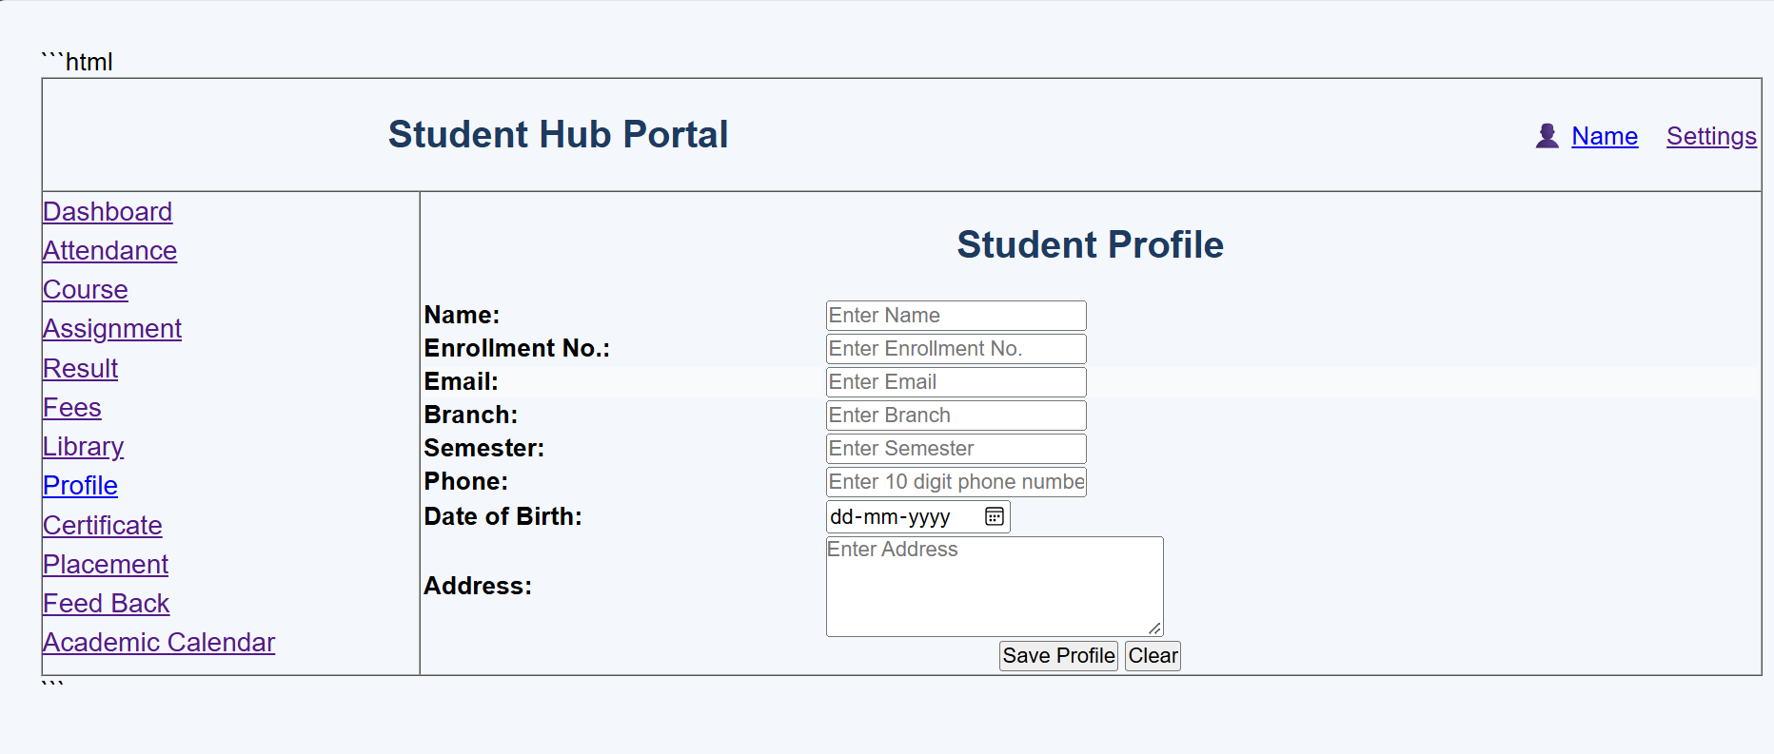
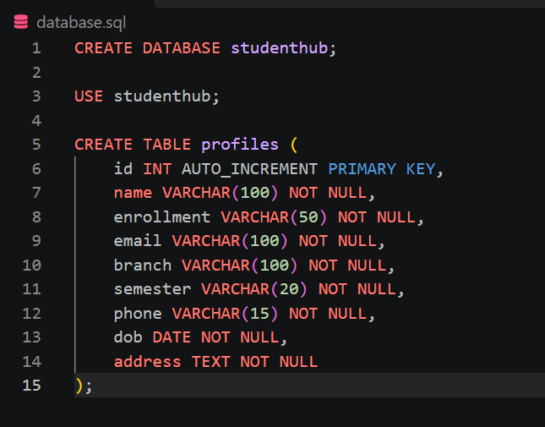
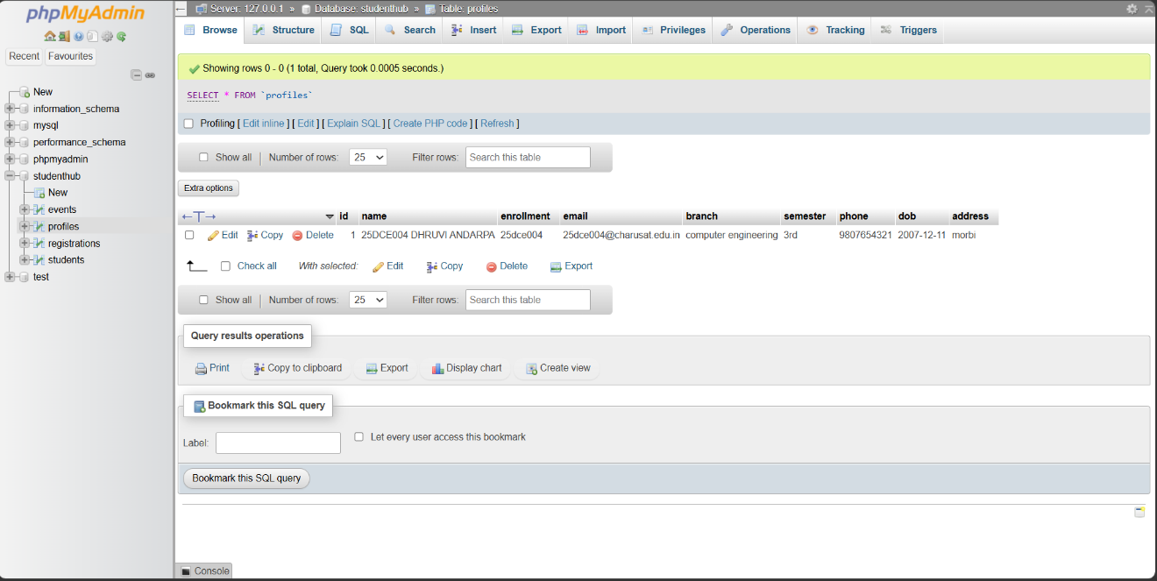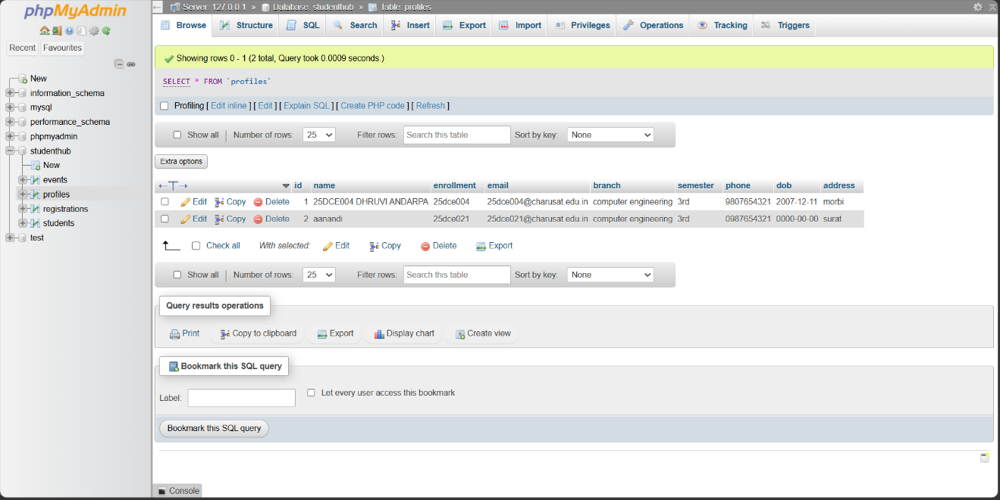
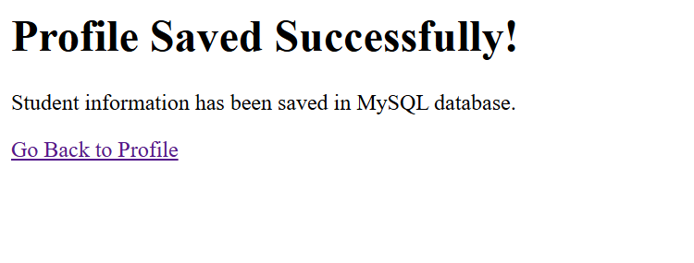
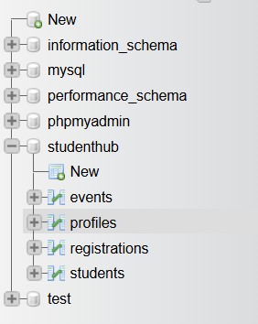

B.GitHub Repository Link:

https://github.com/Andarpadhruvi1125/Student-Hub-portal.git
C.Challenges Faced
During this practical, I faced some difficulties while creating the MySQL database and table. I also faced an error while connecting the PHP page with the MySQL database. Understanding PDO connection and prepared statements was a little difficult at first. I also had to make sure that the form field names and database column names were correct.
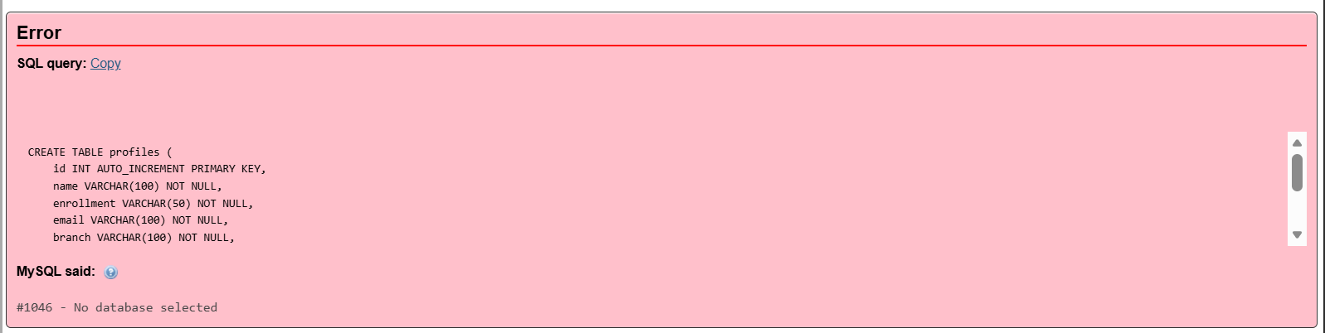
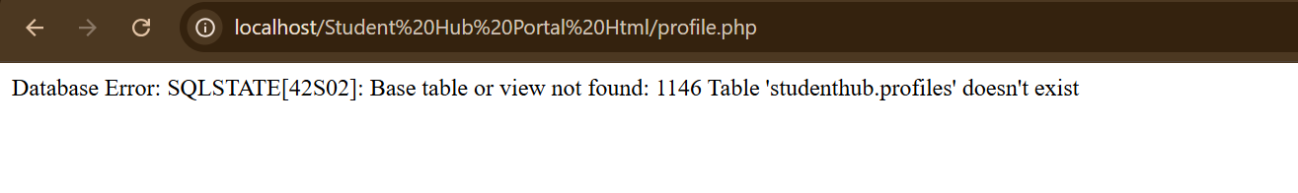

D.Learning Outcomes
From this practical, I learned how to create a MySQL database and table and connect PHP with MySQL using PDO. I learned how to insert form data into a database using prepared statements. I also understood the basic concepts of database schema, primary keys, and secure database operations.

Faculty Remarks:

